

Financial Management System with Machine Learning Support

Chapter 3

Caleigh Susan Anak Jeffry

Bachelor of Software Engineering with Honours
2025
Table of Contents
Contents
3.1 Introduction 1
3.2 Agile Methodology 1
3.2.1 Scrum Framework 2
Product Backlog 2
Sprint Planning 2
Sprint Execution (Development Phase) 3
Sprint Review 3
Sprint Retrospective 3
Product Increment 3
3.3 User Requirement Gathering 4
3.3.2 Finding and Analysis 4
3.3.2.1 Demographic 5
3.3.2.2 Financial Behaviour and Expense Management Practices 7
3.3.2.3 Users With Prior Experience in Expense Tracking 10
3.3.2.4 Users Without Prior Experience in Expense Tracking 14
3.3.2.5 User Expectations and System Requirements 17
3.4 System Design 19
3.4.1 Use Case Diagram 20
3.4.2 Activity Diagram 22
3.4.3 System Architecture 23
3.4.4 User Interface 24
3.5 Chapter Summary 28
References 29

3.1 Introduction
This chapter outlines the methodological framework adopted in the development of Spendette, a financial management system designed to support both personal and shared expenses. This chapter is divided into three components which are the methodology of project execution, the requirement analysis, user interfaces and system designs. These major components provide a structured foundation for the system’s development, ensuring technical accuracy is balanced with user-centred design principles.

3.2 Agile Methodology
The development of Spendette, a financial management system with machine learning support will be completed using the Agile methodology, specifically Scrum framework. Srivastava et al. (2017) mentioned that Scrum is an agile framework that combines iterative and incremental models, enabling successive builds with expanding functionality for object-oriented software development.
Agile support continuous learning, progressive refinement and manageable task segmentation as it breaks the development work into smaller iterations called sprints. Each sprint focuses on completing a specific set of features that enable the review of progress frequently, identify issues early and adjust development plan as needed. This advantages of sprint are important for the development of Spendette as this system combines financial tracking, web development and machine learning where requirement and technical decisions may evolve as the project progresses. Additionally, the iterative nature of Agile help in refining the machine learning model training results and adjusting the system performance during development. Agile provides the adaptibily, clarity and incremental structure to manage and deliver Spendette.

3.2.1 Scrum Framework
In this section, the framework of Scrum Methodology will be outlined. The Scrum framework consists of Product Backlog, Sprint Planning, Sprint Execution, Sprint Review, Sprint Retrospective and Product Increment. Figure 3.2.1.1 below shows the breakdown of Scrum Framework.
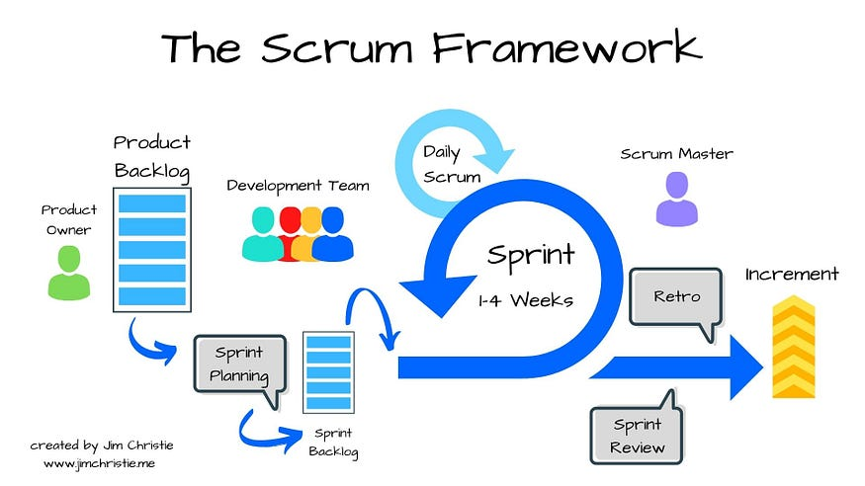
Figure 3.2.1 Scrum Framework
Source: https://share.google/images/Vv92JcPmkuQuWGzCL

Product Backlog
The product backlog is an ordered list of prioritized system features and requirements that define the overall scope of this financial management system project. Acorrding to Alsaqqa et al. (2020), the product backlog is established to document user requirement which are subsequently analysed, prioritized and estimated by the product owner. Based on the user requirement analysed and derived in Section 3.3, the backlog items include core functional and non-functional requirements. The backlog items will be prioritised to ensure that core feature of Spendette are implemented before advanced analytical and intelligent components.

Sprint Planning
Sprint planning will be conducted at the beginning of each sprint to select high-priority items from the product backlog for development of Spendette. During this phase, the project will define the sprint objectives, break down the task into smaller development activities and perform estimation of effort. For this project, sprint planning focuses on scheduling task related to system design, database implementation, user interface development and machine learning model integration. This planning ensures a structured and manageable development timeline.

Sprint Execution (Development Phase)
During sprint execution, the project will design, implement and test the selected backlog items. This phase involved implementing key system components including personal and shared expense management modules and machine learning model. System design such as use case diagram, activity diagram, system architecture and user interface designs will be produced and refined during this phase and are presented in Section 3.4. Additionally, continuous testing and debugging will be carried out to ensure the system functionality, data accuracy and overall reliability.

Sprint Review
Sprint review will be conducted at the end of each sprint to evaluate the completed functionalities of the Spendette. The implemented features will be reviewed against the defined sprint goals and user requirements. The demonstration of the functionalities will be conducted to assess system performance and usability. Feedback obtained during each review will guide the process of refining existing features and update the product backlog for subsequent sprints.

Sprint Retrospective
Sprint retrospective focuses on reflecting upon the development process to identify strength, challenge and areas for improvement. In this project, the retrospective will be evaluated through a few aspects such as time management, task prioritisation, technical challenge encountered during the machine learning integration and overall development efficiency. The insights gained form each retrospective will be applied to improve development strategies and enhance system quality in future sprints.

Product Increment
Each sprint will produce a usable product increment of Spendette that include a new or enhanced functionalities. These incremental releases will ensure continuous progress toward the completion of a fully functional financial management system that meets user requirements and project objectives.

3.3 User Requirement Gathering
User requirements for Spendette were collected using a structured online survey. This method was chosen for its efficiency in gathering consistent data from a large group of respondents within a short period. The survey was distributed to 50 university students, who represent the target users of the system.
The online survey consisted of close-ended and open-ended questions covering demographic information, financial behaviour, prior use of expense tracking applications and expected system features. The collected data were analysed using descriptive statistics to identify key user requirements and inform the system design.

3.3.2 Finding and Analysis
This section presents the results obtained from the survey conducted to evaluate user perceptions and requirements for the financial management system. The collected data is analysed to identify the users’ requirements and to ensure it align with the system’s design objectives.

3.3.2.1 Demographic
The section aims to provide an overview of the respondents’ background and to ensure that the survey participants represent the intended target group, which is university students. This section collects basic information on respondents’ level of study and gender, allowing for a general understanding of the participant profile.
- Question: Current level of study.
Type: Multiple-choice question with single selection allowed.
Description: This question identifies the academic level of respondents which are Diploma, Bachelor’s, or Postgraduate. The main purpose of this question is to ensure that the survey participants represent the intended target group, which is university students. Figure 3.3.2.1.1 and Table 3.3.2.1.1 below show the result of the survey for this question.
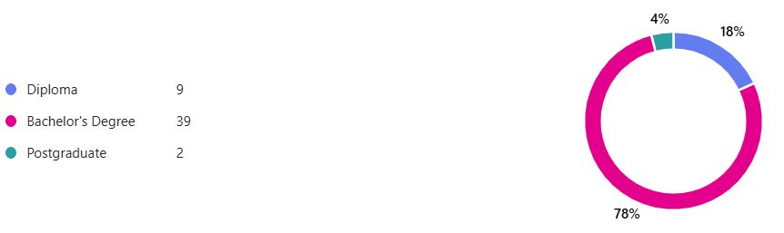
Figure 3.3.2.1.1 Distribution of Respondents by Level of Study

Level of Study | Total
Diploma | 9 Respondents
Bachelor’s Degree | 39 Respondent
Postgraduate | 2 Respondents
Table 3.3.2.1.1 Summary of Respondents’ Educational Level

- Question: Gender
Type: Multiple-choice question with single selection allowed.
Description: This question identifies the gender distribution of respondents to explore whether gender influences responses regarding financial habits or system preferences. Figure 3.3.2.1.2 and Table 3.3.2.1.2 below show the result of the survey for this question.
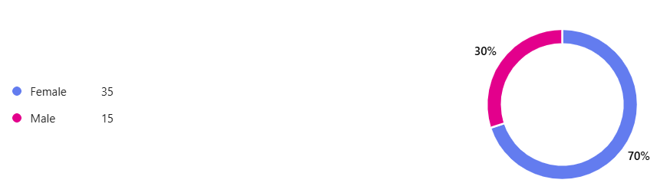
Figure 3.3.2.1.2 Distribution of Respondents by Gender

Level of Study | Total
Female | 35 Respondents
Male | 15 Respondent
Table 3.3.2.1.2 Summary of Respondents’ Gender

3.3.2.2 Financial Behaviour and Expense Management Practices
This section aims to examine respondents’ financial behaviour and expense management practices, including sources of income, preferred payment methods, sharing habits and current use of expense tracking tools. The findings provide insight into the financial management habits of university students and help identify needs and opportunities for the proposed expense tracking system.
- Question: Which type of income do you usually receive?
Type: Multiple-choice question with multiple selection allowed.
Description: This question identifies the main sources of income for respondents, such as family allowance, scholarship/financial aid, part-time job income or other sources. Understanding income sources helps contextualize respondents’ financial management behaviour and potential reliance on expense tracking tools. Figure 3.3.2.2.1 and Table 3.3.2.2.1 below show the result of the survey for this question.
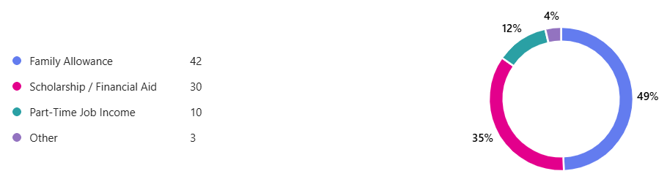
Figure 3.3.2.2.1 Types of Income Received by Respondents

Type of Income | Total
Family Allowance | 42 Answers
Scholarship/ Financial Aid | 30 Answers
Part-Time Job Income | 10 Answers
Other: “Savings”, “Working Salary” & “Allowance” | 3 Answers
Table 3.3.2.2.1 Summary of Respondents’ Income Sources
- Question: Which payment methods do you commonly used for daily transactions?
Type: Multiple-choice question with multiple selection allowed.
Description: This question investigates the payment methods respondents commonly use, including cash, debit/credit cards, e-wallets or online banking. Figure 3.3.2.2.2 and Table 3.3.2.2.2 below show the result of the survey for this question.
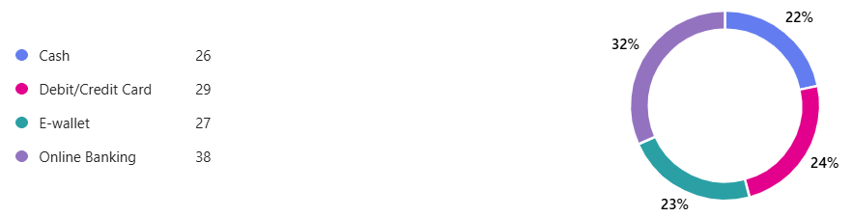
Figure 3.3.2.2.2 Distribution of Payment Methods Used for Daily Transactions
Payment Method | Total
Cash | 26 Answers
Debit/Credit Card | 29 Answers
E-wallet | 27 Answers
Online Banking | 38 Answers
Table 3.3.2.2.2 Payment Methods Commonly Used for Daily Transactions

- Question: Do you often share expenses with friends?
Type: Multiple-choice question with single selection allowed.
Description: This question determines whether respondents commonly engage in shared expenses with others. Understanding the prevalence of shared expenses is important for including features such as expense splitting in the proposed system. Figure 3.3.2.2.3 and Table 3.3.2.2.3 below show the result of the survey.
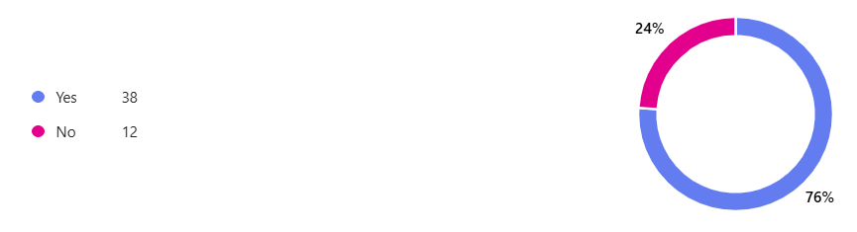
Figure 3.3.2.2.3 Distribution of Respondents Sharing Expenses
Sharing Expenses? | Total
Yes | 38 Respondents
No | 12 Answers
Table 3.3.2.2.3 Proportion of Respondents Sharing Expenses

- Question: Do you currently use any expense tracking or budgeting application?
Type: Multiple-choice question with single selection allowed.
Description: This question identifies respondents who already use expense tracking or budgeting tools. The responses provide insight into user familiarity and readiness to adopt such systems, as well as potential gaps that the proposed system could address. Figure 3.3.2.2.4 below shows the result of the survey for this question.

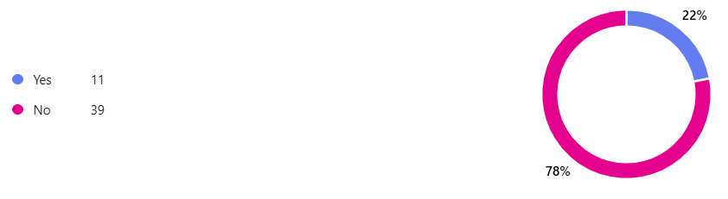
Figure 3.3.2.2.4 Distribution of Respondents With and Without Prior Experience to Expense Tracking System

There are 39 respondents that do not currently use expense tracking tools, suggesting that first-time adoption and user-friendly onboarding are important considerations for the proposed system. There are 11 respondents who have experience using expense tracking.

3.3.2.3 Users With Prior Experience in Expense Tracking
This section focuses on respondents who have previously used expense tracking systems. The aim is to understand their experiences, usage patterns, satisfaction and perceived limitations. Insights from this group help identify common challenges and opportunities for feature improvements in the proposed system. There 11 respondents who have prior experience with expense tracking system.
- Question: How frequently did you use the expense tracking system?
Type: Multiple-choice question with single selection allowed.
Description: This question investigates how often respondents used their previously adopted expense tracking systems. Frequency of use provides insight into user engagement and consistency, which are important factors in designing a system that encourages regular and effective financial tracking. Figure 3.3.2.3.1 and Table 3.3.2.3.1 below show the result of the survey for this question.
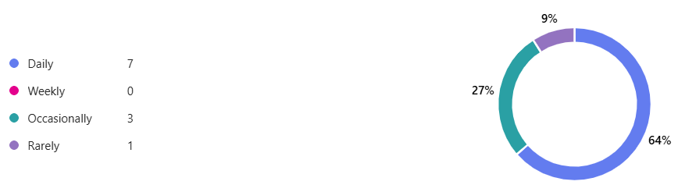
Figure 3.3.2.3.1 Respondents’ Usage Frequency of Expense Tracking Systems

Frequency | Total
Daily | 7 Respondents
Weekly | 0 Respondent
Occasionally | 3 Respondents
Rarely | 1 Respondent
Table 3.3.2.3.1 Frequency of Using Expense Tracking Systems

- Question: What limitations did you encounter while using expense tracking system?
Type: Multiple-choice question with multiple selection allowed.
Description: This question aims to identify the challenges or limitations respondents faced while using expense tracking systems. By allowing multiple selections, the survey captures a range of difficulties such as complex interfaces, inadequate financial insights, limited shared expense management or lack of customization. These insights highlight areas for improvement in system design. Figure 3.3.2.3.2 and Table 3.3.2.3.2 below show the result of the survey for this question.
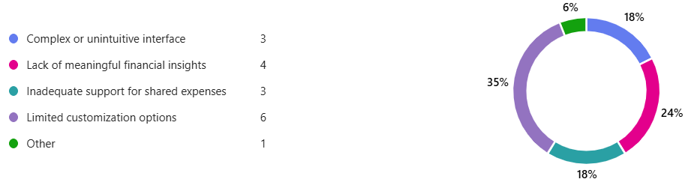
Figure 3.3.2.3.2 Distribution of Limitations Encountered in Using Expense Tracking Systems

Limitation | Description | Total
Complex or unintuitive interface | Users struggled with difficult navigation or poor design. | 3 Answers
Lack of meaningful financial insights | System did not provide useful reports or guidance | 4 Answers
Inadequate support for shared expenses | Difficulty managing group or shared costs | 3 Answers
Limited customization options | Unable to adjust categories, budget limits, or notifications | 6 Answers
Other: “Lack of ability to understand different categories of expenses and warn that some is too high from normal.” | System could not categorize expenses effectively or alert users when spending in a category was unusually high, indicating a need for smarter categorization and overspending notifications. | 1 Answer
Table 3.3.2.3.2 Limitations Experienced by Users of Expense Tracking Systems
- Question: Overall, how satisfied were you with the expense tracking system you used?
Type: Likert Scale
Scale Used:
- Very Dissatisfied
- Dissatisfied
- Neutral
- Satisfied
- Very Satisfied
Description: This question assesses respondents’ overall satisfaction with the expense tracking system they previously used. Measuring satisfaction helps evaluate the effectiveness and usability of existing systems and provides a benchmark for features that should be improved or maintained in the proposed system. Figure 3.3.2.3.3 and Table 3.3.2.3.3 below show the result of the survey for this question.

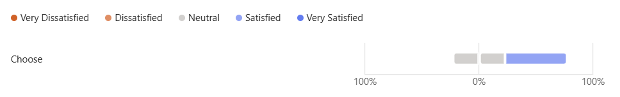
Figure 3.3.2.3.3 Respondents’ Overall Satisfaction with Expense Tracking Systems

Level of Satisfaction | Total
Very Dissatisfied | 0 Respondent
Dissatisfied | 0 Respondent
Neutral | 5 Respondents
Satisfied | 6 Respondent
Very Satisfied | 0 Respondent
Table 3.3.2.3.3 Overall Satisfaction with Expense Tracking Systems

- Question: What improvements or additional features would you expect from an ideal expense tracking system?
Type: Open-ended question.
Description: This open-ended question gathers respondents’ suggestions and expectations for an ideal expense tracking system. The aim is to identify desirable features and enhancements that address user pain points and improve usability, functionality, and engagement. The responses guide the development of a system that meets real user needs and expectations. The Table 3.3.2.3.4 below describe the finding and analysis of this question.

Item | Description
Enhanced Budgeting & Alerts | Features for budget planning and overspending alerts
User-Friendly Interface & Convenience | Easier navigation and better design.
Shared & Personal Expense Management | Features to distinguish and manage shared and personal expenses
Intelligent Categorization & Spending Insights | System recognizes expense categories and warns about abnormal spending
Bill Reminders | Receiving reminders for bills
Table 3.3.2.3.4 Suggested Improvements and Additional Features for an Ideal Expense Tracking System

3.3.2.4 Users Without Prior Experience in Expense Tracking
This section involves 39 respondents who have no prior experience using expense tracking systems. It aims to understand how they currently manage expenses, the challenges they face, and the features or benefits that would encourage them to adopt an expense tracking system. The responses provide valuable insights into user needs and expectations, which help inform the design of a simple, effective and user-friendly Spendette system for first-time users.
- Question: How do you currently manage your personal and shared expenses?
Type: Multiple-choice question with single selection allowed.
Description: This question investigates the current approaches adopted by respondents to manage their personal and shared expenses. It helps identify patterns in financial management practices and highlights areas where users may face difficulties, which can be addressed through the proposed system. By understanding their existing behaviours, the study can identify gaps and inefficiencies in expense management. Figure 3.3.2.4.1 and Table 3.3.2.4.1 below show the result of the survey for this question.
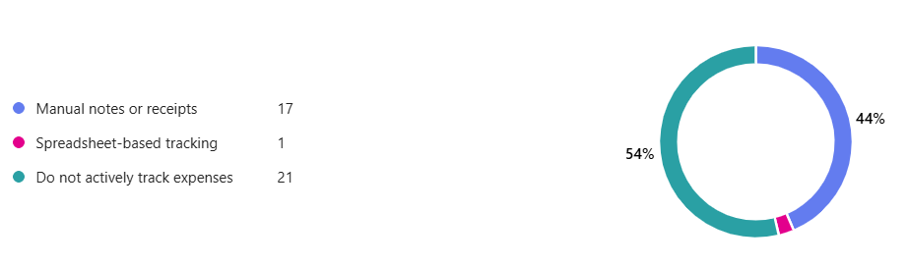
Figure 3.3.2.4.1 Respondents’ Methods for Managing Personal and Shared Expenses

Method | Description | Total
Manual notes or receipts | Users record expenses on paper or keep physical receipts | 17 Respondents
Spreadsheet-based tracking | Users use Excel, Google Sheets, or similar tools to track expenses | 1 Respondent
Do not actively track expenses | Users do not keep records or monitor expenses regularly | 21 Respondents
Table 3.3.2.4.1 Summary of Current Methods of Managing Personal and Shared Expenses
- Question: What challenges do you commonly face in managing your expenses?
Type: Multiple-choice question with multiple selection allowed.
Description: This question examines the challenges faced by respondents in managing personal and shared expenses. Respondents could select multiple issues, allowing the identification of recurring difficulties and their prevalence. The findings provide insights into the most common problems users face, which can guide the design of the proposed expense tracking system to better meet user needs. Figure 3.3.2.4.2 and Table 3.3.2.4.2 below show the result of the survey for this question.
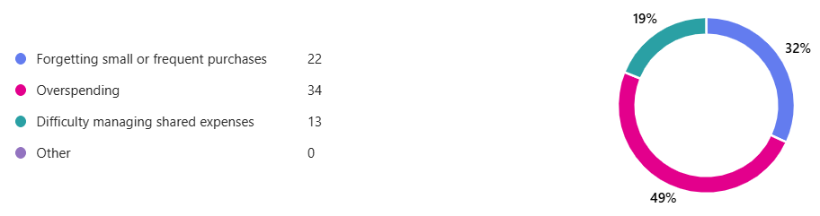
Figure 3.3.2.4.2 Distribution of Challenges Encountered in Managing Expenses

Challenge | Description | Total
Forgetting small or frequent purchases | Users often forget to record or remember minor expenses | 22 Answers
Overspending | Users struggle to stay within their budget | 34 Answers
Difficulty managing shared expenses | Users find it hard to track shared/group spending accurately | 13 Answers
Other | Challenger mentioned by respondents | 0 Answer
Table 3.3.2.4.2 Common Challenges Faced in Managing Expenses

- Question: What features or benefits would encourage you to start using an expense tracking system?
Type: Open-ended question.
Description: This question explores the expectations that would encourage first-time users to adopt the proposed system. the findings provide a valuable insight into functional and non-functional feature prioritization for the proposed system. The Table 3.3.2.4.3 below describe the finding and analysis of this question.
Item | Description
Budget Control & Overspending Alerts | Features that help users monitor spending and prevent exceeding budget limits.
Automated Expense Tracking | Automation that reduces manual effort for first-time users.
Ease of use of User Interface (UI/UX) | Simple, intuitive and visually appealing design suitable for beginners
Budget Planning & Financial Guidance | Guidance features to assist users with budgeting.
Saving & Financial Goal | Features that encourage saving habits and financial discipline
Shared Expense Management | Tools to manage shared expenses accurately
Notifications & Reminders | Alerts that support consistent usage and awareness.
Table 3.3.2.4.3 Summary of Respondents’ Desired Features or Benefits for an Expense Tracking System

3.3.2.5 User Expectations and System Requirements
This section gathers respondents’ expectations regarding the features and characteristics of an ideal expense management system, specifically for the proposed system, Spendette. The questions are designed to measure the perceived importance of key system features and to collect additional user suggestions.
- Question: Please indicate your level of agreement on the importance of the following proposed features for Spendette.
Type: Likert Scale Question
Scale Used:
  - 1 – Strongly Disagree
  - 2 – Disagree
  - 3 – Neutral
  - 4 – Agree
  - 5 – Strongly Agree
Description: This question uses a five-point Likert scale to measure respondents’ level of agreement with the importance of various proposed features in the Spendette system. The features include expense recording, income tracking, transaction history, expense categorization, group expense management, fixed bill management and the use of machine learning for expense management. The Figure 3.3.2.5.1 below describe the finding of this question.

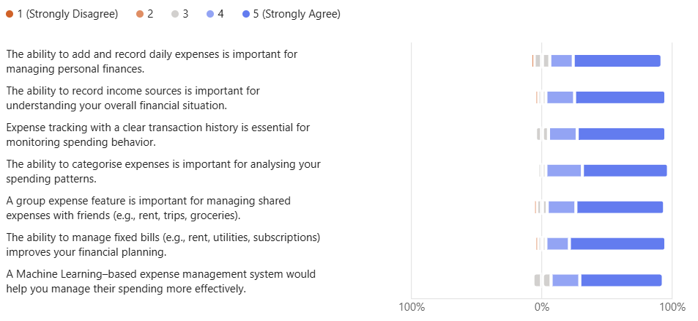
Figure 3.3.2.5.1Respondents’ Level of Agreement on the Importance of Proposed Features
Based on the collected data, the findings indicate a high level of agreement with all proposed features of the Spendette system. Firstly, 68% of respondents strongly agreed, 18% agreed, 12% were neutral and 2% strongly disagreed that the ability to add and record daily expenses is important for managing personal finances. This indicates that basic expense entry is a core requirement. Similarly, the ability to record income sources received high agreement, with 70% of respondents strongly agreeing, 22% agreeing, 3% being neutral and 2% strongly disagreeing. This reflects the importance of understanding one’s overall financial standing.
Respondents also showed strong support for expense tracking with a clear transaction history, with 68% strongly agreeing, 22% agreeing and 3% being neutral. This emphasizes the need for transparency and easy monitoring of spending behavior. The ability to categorise expenses was also highly valued, as 66% of respondents strongly agreed, 28% agreed and 3% were neutral. This capability enables users to analyse spending patterns more effectively.
In addition, most respondents agreed that a group expense feature is important for managing shared expenses such as rent, trips and groceries. This is reflected by 68% strongly agreeing, 22% agreeing, 8% being neutral and 2% disagreeing, highlighting the relevance of this feature for university students. The ability to manage fixed bills was also rated positively, with 74% strongly agreeing, 18% agreeing, 6% being neutral and 2% neutral. This suggests that users want better financial planning and bill management support.
Finally, responses to the Machine Learning–based expense management feature showed a high level of agreement, with 64% of respondents selecting “Strongly Agree”, 22% selecting “Agree” and 14% being neutral. This indicates strong user acceptance and confidence that intelligent features, such as automated insights and spending analysis, would enhance the overall effectiveness of the Spendette system.

- Question: Do you have any additional suggestions or expectations for the Spendette system?
Type: Open-ended question.
Description: This open-ended question was included to allow respondents to freely express additional suggestions, expectations or opinions regarding the Spendette system that were not covered in the predefined questions. The purpose of this question is to capture qualitative insights on desired features, usability improvements and concerns such as convenience, security and financial awareness. The Table 3.3.2.5.2 below describe the finding of this question.

Item | Description
User-Friendly Interface & Navigation | Preference for a simple, clear, and non-complicated interface that supports quick usage.
Budget Alerts & Overspending Notifications | Alerts or reminders when spending exceeds daily or category limits
Reports & Visual Summaries | Visual representation of expenses and income
Cross-Device Access | Ability to sync data across devices.
Table 3.3.2.5.2 Additional Suggestions and Expectations for the Spendette System

3.4 System Design
This section presents the system design of the Spendette Web Application. The system design illustrates how users interact with the system and how system components are structured and connected. The design is represented using use case diagrams, activity diagrams, system architecture and user interface designs to ensure efficient system operation.

3.4.1 Use Case Diagram
As shown in Figure 3.4.1.1, the use case diagram for the Spendette Web Application provides a high-level overview of the system’s functional requirements. This illustrates the interaction between external actor and the system itself. The use case diagram serves as a foundational artifact in understanding system boundaries and feature dependencies.

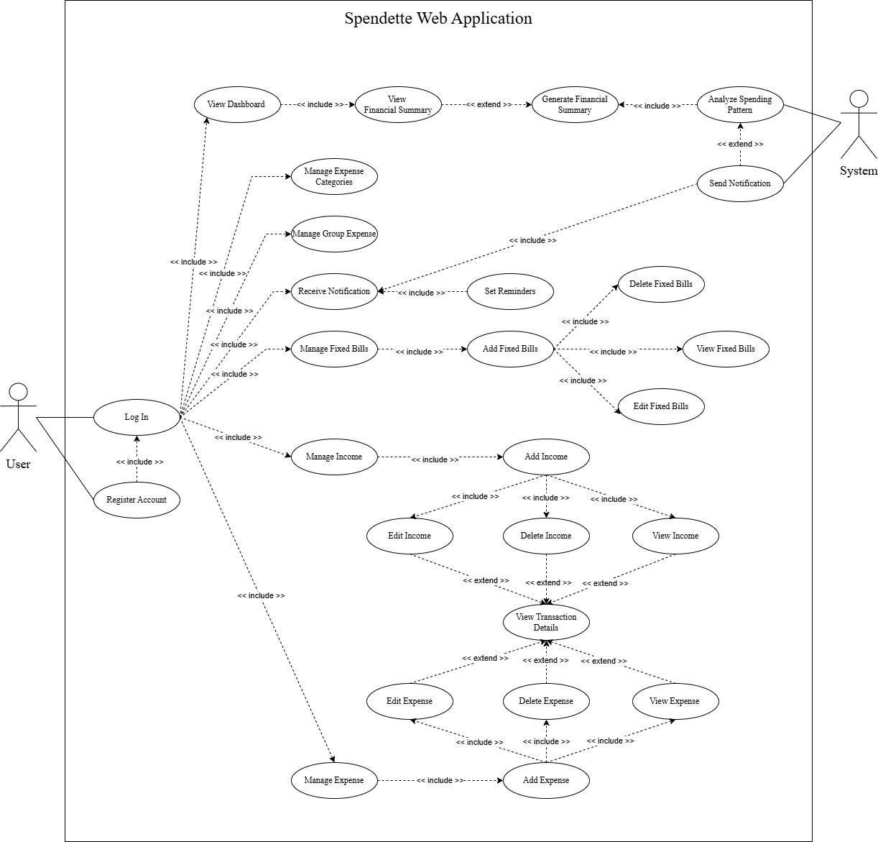
Figure 3.4.1.1 Use Case Diagram for Spendette Web Application

Actors:
- User: Represents the primary end-user who interacts with the application.
- System: An internal actor responsible for automated processes.
Use Cases:
- Authentication and Access
- Register Account
- Log In
- Financial Management
- Manage Expense Categories
- Manage Group Expense
- Manage Fixed Bills
- Manage Income
- Manage Expense
- View Transaction Details
- Data Visualisation and Insights
- View Dashboard
- View Financial Summary
- Generate Financial Summary
- Notification and Reminder
- Send Notification
- Receive Notification
- Set Reminders
- Machine Learning
- Analyse Spending Pattern
Relationship:
- << include >> Relationship: Indicates mandatory sub-processes that are always executed as part of the base use case.
- << extend >> Relationship: Represent optional or conditional behaviour that enhance the base use case when certain criteria are met.

3.4.2 Activity Diagram
As shown in the Figure 3.4.2.1, the activity diagram for Spendette Web Application illustrate the flow of user interactions and system responses. This capture both sequential actions and decision-based branching. On the user side, activities begin with logging in or registering, followed by navigating the homepage and viewing notifications. Next, user can choose to manage financial data such as expenses, income, fixed bills and group expenses. Each of these tasks involves detailed steps like entering information, selecting categories and saving records. Users can also navigate to the dashboard and view the financial summary, which provides insights into their overall financial status. On the system side, Spendette manages authorization, profile creation and data collection, while also performing automated analysis of spending behaviour. This diagram effectively models the operational logic making it a valuable tool for understanding workflow and system behaviour.

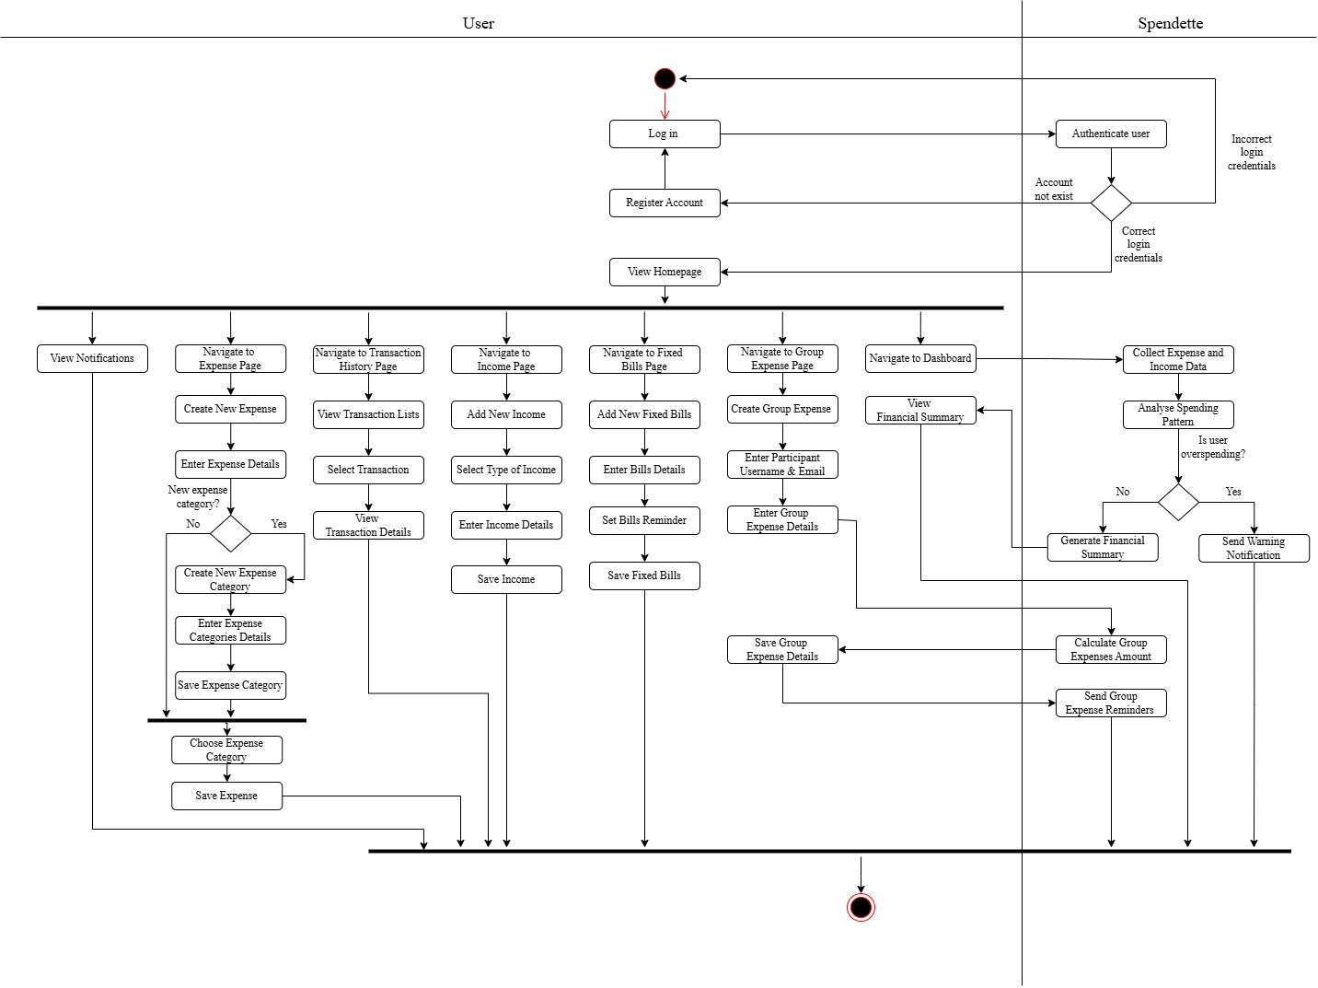
Figure 3.4.2.1 Activity Diagram

3.4.3 System Architecture
The system architecture describes the overall structure of the system and the interaction between its components. The proposed system adopts a three-tier architecture consisting of the presentation tier, application tie and data tier. The presentation tier includes the client-side components such as the web browser and frontend interface developed using HTML, CSS and JavaScript. The application tier handles server-side processing using PHP, web server and machine learning model. The data tier consists of database that stores user data, transaction records and historical datasets.
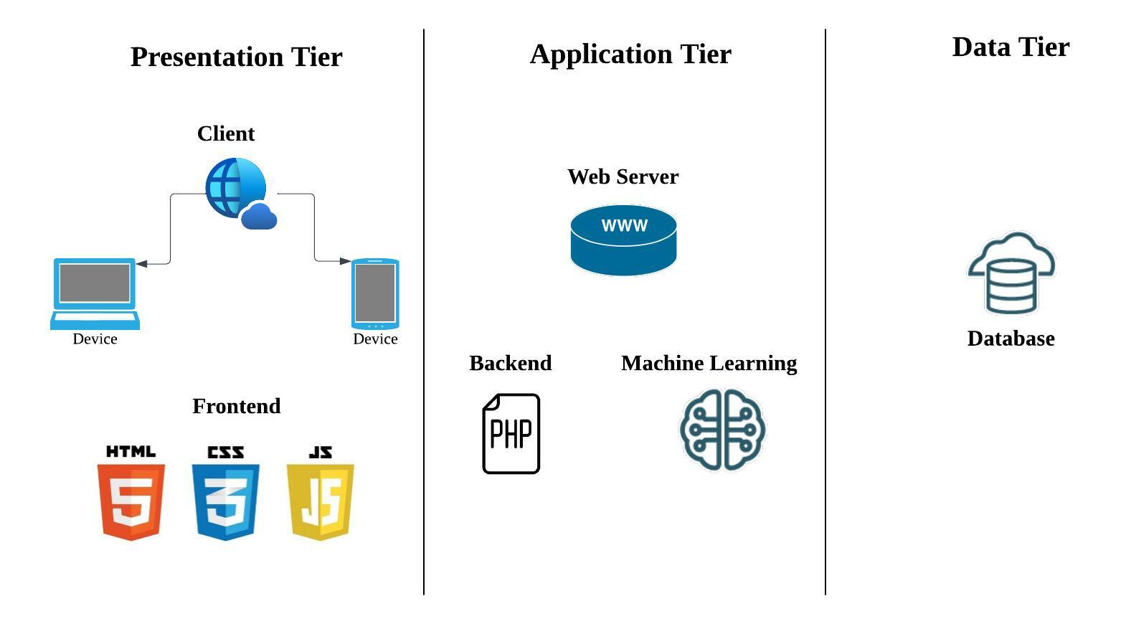
Figure 3.4.3.1 System Architecture

3.4.4 User Interface
This section describes the user interface design of the Spendette, with an emphasis on usability, consistency and visual clarity. The interface is designed to be user-friendly and intuitive that allow users to navigate the system easily with minimal learning effort. Key design principles such as clear layout structure, appropriate colour usage, readable typography and logical placement of components are applied to enhance overall user interaction. The figures below show the user interface for the core features in Spendette Web Application.

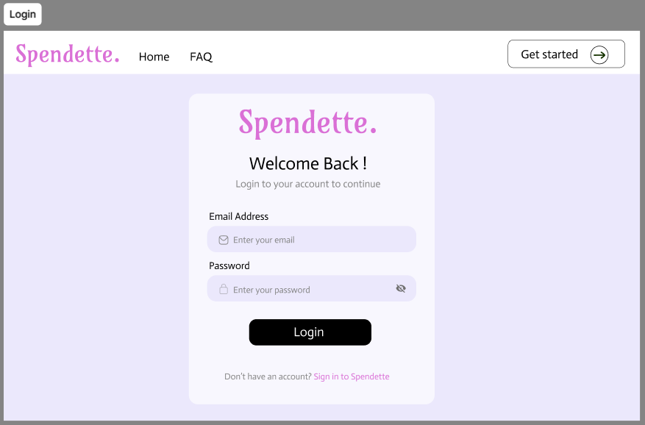
Figure 3.4.4.1 Login Page of Spendette Web Application

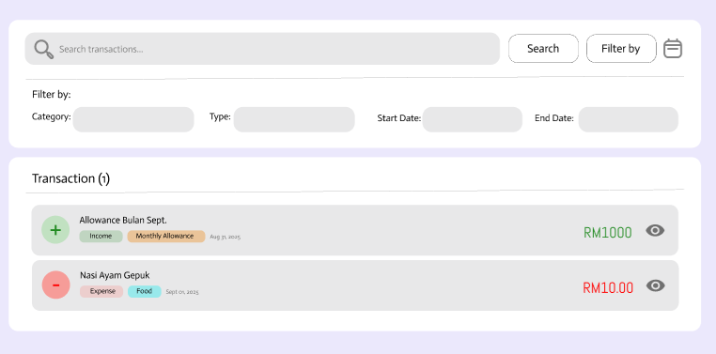
Figure 3.4.4.2 Transaction List Page in Spendette Web Application

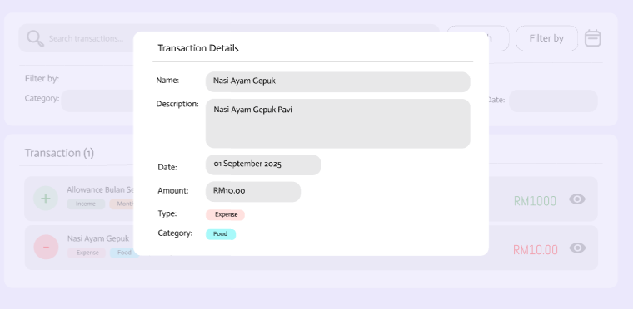
Figure 3.4.4.3 View Transaction Details

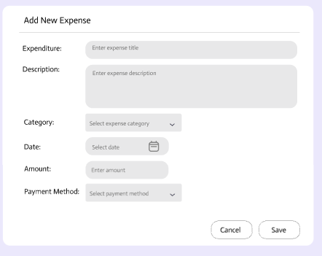
Figure 3.4.4.4 Add New Expense Form

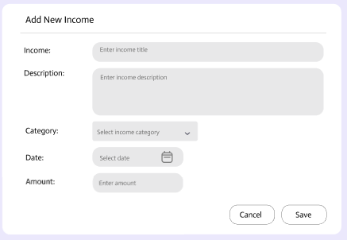
Figure 3.4.4.5 Add New Income Form

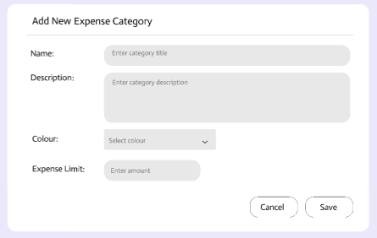
Figure 3.4.4.6 Create New Expense Category

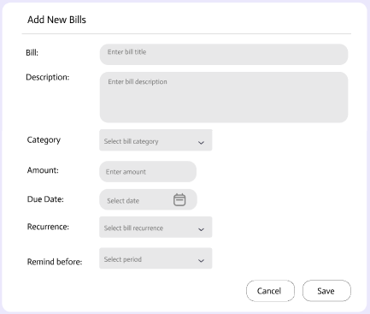
Figure 3.4.4.7 Add New Fixed Bills Feature
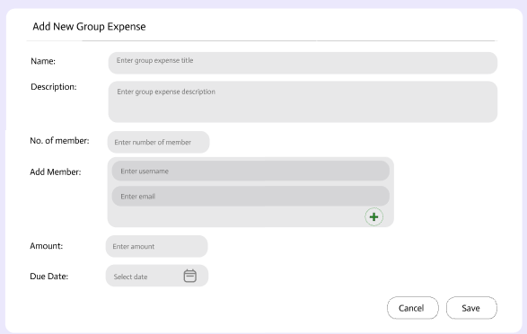
Figure 3.4.4.8 Create Group Expense Feature

3.5 Chapter Summary
This chapter presented the methodology adopted for the development of the proposed system. It outlined the overall research approach, system architecture, development tools, and technologies used throughout the project. The chapter also described the system design, including database structure, functional modules, and user interface flow, to ensure the system meets the identified requirements.

References
Alsaqqa, S., Sawalha, S., & Abdel-Nabi, H. (2020). Agile Software Development: Methodologies and Trends. International Journal of Interactive Mobile Technologies (iJIM), 14(11), 246. https://doi.org/10.3991/ijim.v14i11.13269
Srivastava, A., Bhardwaj, S., & Saraswat, S. (2017). SCRUM model for agile methodology. 2017 International Conference on Computing, Communication and Automation (ICCCA), pp. 864-869. https://ieeexplore.ieee.org/document/8229928

